A Robust Face Authentication Framework with CNN-Based Anti-Spoofing for Intelligent Attendance Systems
Riteek Raj Tiwari¹, Rohit Raj¹, Arya Kumari¹, Shubham Kumar¹
¹Mahatma Gandhi Central University, Motihari, India
Abstract
In recent years, the field of deep learning and computer vision has seen significant advancement, enhancing automated attendance systems. In this paper, a deep learning-based liveness-verified biometric attendance management system (LBAMS) is proposed. It aims to alleviate the issues related to the traditional methods of attendance, including manual roll calls, paper-based attendance logs, and proxy attendance. The traditional method is inefficient, inaccurate, and insecure as students can easily mark fake attendance. The system proposed is composed of facial recognition, liveness detection, and automatic data management, all within a secure system. The system pre-processes the image using Adaptive Histogram Equalization (AHE) to enhance the recognition in different lighting conditions. Natural eye blinking is also detected using the Eye Aspect Ratio (EAR) analysis and an anti-spoofing technique based on Convolutional Neural Network (CNN). It makes it easier for the system to determine if its a person or an image, photo or fake. This means that only those who attend in person can be marked as present. Once liveness is confirmed, the features of the face are mapped into embeddings of high dimension. Once liveness is validated, the facial features are transformed to high-dimensional embeddings. These features are then compared to stored templates of biometrics through Euclidean distance-based face recognition. It is a system designed using computer vision techniques in python, django backend and a sqlite database. The workforce is earmarked on the fly; data is secured and stored; and reports are generated automatically in Excel and PDF. The experimental results indicate that the developed system can achieve high recognition accuracy and good resistance to spoofing attacks in practical classrooms. This system minimizes attendance manual labor and enhances security and transparency over the conventional attendance system. The researchers conclude that the proposed solution is reliable, scalable and affordable for use in educational institutions and organizations.
Keywords
Face Recognition, Anti spoofing, Biometric Attendance System, Convolutional Neural Network, Computer Vision
- INTRODUCTION
The issue of attendance management in the educational institutions is of critical importance. Very few organizations employ modern technology like an attendance system. These techniques are more time-consuming and may easily result in human mistakes [1]. Save time and effort by avoiding the issue of "proxy attendance" in manual attendance systems, in which students record the attendance of classmates when they are absent. This has an impact on the integrity and credibility of the grade records [2]. For better process, there have been adoption of biometric systems like RFID card and fingerprint scanner are adopted. These systems were useful for the automation of attendance marking, but brought in new difficulties as well. RFID cards can be lost, and fingerprint scanners need periodic maintenance and can have hygiene issues [3].
The development of computer vision technology makes facial recognition an accurate alternative solution that is less invasive for tracking students' attendance [4]. This technology can be used for attendance without the need for physical contact, thereby saving classroom time and making attendance easier [5]. Previously, simpler feature extraction techniques like Principal Component Analysis (PCA) were used. The modern systems are using the advanced deep learning models such as Convolutional Neural Network (CNN) for getting more accurate results in different environmental conditions [6][7]. Facial recognition systems have become affordable and suitable for large-scale applications with the use of low-cost devices like Raspberry Pi and open source libraries such as OpenCV [8]. Recently, the creation of liveness detection techniques that can help to reject phishing attempts via photos or videos [9] has been introduced. In institutions, the entire attendance management procedure, ranging from face detection to report generation, is automated, ensuring a secure, transparent, and efficient approach for attendance management [10].
Agustiyar et al. [11] surveyed the development of attendance systems in the period 2019-2024. They found that attendance systems are quickly changing from manual methods to AI-based systems. Their research indicated that the deep learning models, particularly Convolutional Neural Networks (CNNs) are extensively employed in the present research. They also determined that the three countries are in the forefront in this sector, namely India, Indonesia and Malaysia. The researchers, however, said there was little international cooperation making it hard to build a variety of facial datasets. A problem that was discussed by Suaib et al., is the problem of large classrooms where manual attendance is prone to errors and fake attendance [12]. They suggested the machine learning system based on CNNs for accurate face recognition. Their research indicated that using automated attendance systems helps to monitor students and decreases errors. The system not only showed high recognition rate but also showed very low false-positive rate. A smart attendance system was developed by Shirbhate et al. [13] that works by recognizing faces using python and stores the results in a PHP/MySQL database. System offers real-time attendance monitoring and management. It takes the place of paper attendance sheets and decreases proxy attendance. The study also concluded that the software-based system is cost effective and feasible for large institutions. Patil and Shukla [14] recommended an inexpensive hardware system which uses Raspberry pi and the Viola Jones algorithm for detecting faces. They found that it is possible to achieve real time attendance tracking without the need for costly servers. The system can accurately recognize faces under different background. The study demonstrated the benefits of using portable devices to conserve class time and increase attendance accuracy. Patel et al. [15] integrated the IoT or Internet of Things technology with facial recognition. Their system allows them to notify parents/supervisors automatically of absences. The results of the study demonstrated that the integration of biometrics and cloud-based IoT enhances data security and reporting. To prevent spoofing attacks, Potharwat et al. [16] proposed a CNN-based liveness detection system. Their model monitors eye blinks and facial movements, to determine if it's a person or a fake. The system was able to gain 93% accuracy correctly identifying photos and video frames employed in fake attendance. Hosen et al [17] have created a system that has been produced to combine attendance management and campus security. LBPH face recognition and DoG filtering anti-spoofing system. It also has a security alert that alerts the administrators that an unauthorized person is detected. To overcome the student attendance problem, Afandy et al. [18] came up with the concept of Adaptive Attendance Monitoring (AAM). They have a system developed which monitors students throughout the lecture via MTCNN and FaceNet. A student must be present for the majority of the class session to receive a "Present" mark. This ensures that the student participation level is a more accurate measurement. Supriatna et al. [19] concentrated on system performance when used under different lighting conditions and face angles. They obtained the accuracy of 98.90% on average. The study demonstrated the benefits of algorithm optimizations and anti-spoofing techniques for enhancing the reliability and security of the system. Bussa et al. [20] is based on the complete automation of attendance taking with the help of OpenCV. They automatically generate attendance in Excel sheets and PDF reports. The study revealed that the automated attendance systems can save manual labor and ensure accurate and organized attendance records.
- Proposed Model
The heart of this research is that of computer vision and web-based data management technologies which are seamlessly integrated to converge and form a robust automatic attendance system without manual intervention. The central idea in this research is an automatic attendance system that integrates computer vision with web-based data management technologies to shift and converge to form a resilient hands-free attendance system. The workflow is optimized to have as little latency as possible, while achieving maximum recognition accuracy under a wide range of environmental conditions.
2.1 Advanced Image Pre-processing
In a regular classroom, standard facial recognition systems are not effective in the real-world of differing light levels and shadows. For this, Adaptive Histogram Equalization (AHE) is used in our system. AHE works on local tiles of the image rather than the entire image, providing contrast measurement information to both shadowed areas and well-lit areas while attempting to avoid over-saturation in any of the areas. AHE does ‘local’ contrast, operating on smaller image portions (tiles) instead of the entire image and avoid over-saturating well-lit areas while providing a measurement of contrast to the shadowed areas. This makes sure that the next layer in the feature model (text feature extraction) layer gets a clean and even feed.
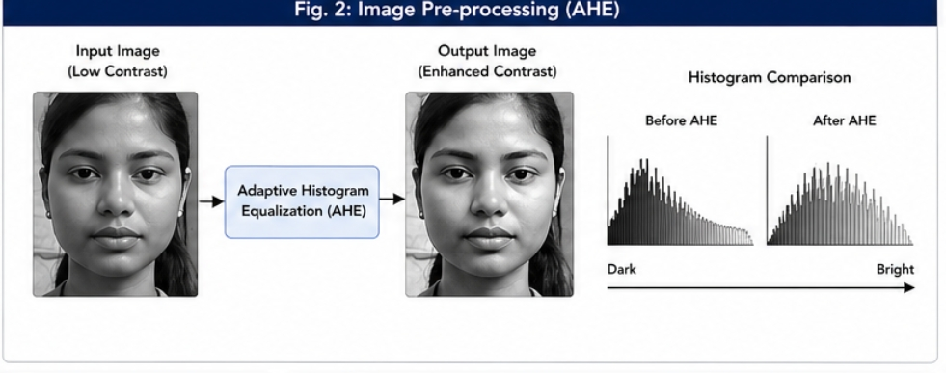
2.2 Dual-Layer Security: The Anti-Spoofing Engine
The main novelty of this work is that a liveness detection protocol has been implemented in the anti_spoofing.py module. We use a Convolutional Neural Network (CNN) and Eye Aspect Ratio (EAR) monitoring.
- EAR Calculation: The ratio of distances between the vertical and horizontal landmarks of the eyes is calculated in the system. If there is a sudden decrease in this ratio and then it returns to normal, it's a real blink!
- Physiological Verification: The system will ensure that the audio player, user number, and video loops were rendered dynamically, which helps to prevent someone who is trying to using "proxy" fraud substituting a high-definition picture or video loop for that of a student.
- Spoof Rejection: When no blink is found or and the pattern is static (as in a picture) it is recognized as a bogus representation and the attendance request is refused. This way only the person/s in the room are recorded.
To perform face anti-spoofing via eye blink detection, the system calculates the Eye Aspect Ratio (EAR). The mathematical model for EAR is adapted from the methodology proposed by Potdar et al. [16].
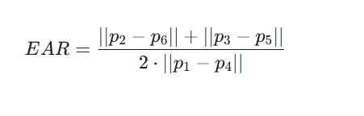
Formula Components Explained:
- Numerator (||P2-P6|| + ||p3-P5||): Measures the sum of the two vertical distances, representing the instantaneous opening width of the eye.
- Denominator (2 ||p1-P4||): Says how far from the camera the subject is, it is used as a scale factor to keep the ratio constant when the subject moves closer or further away from the camera.

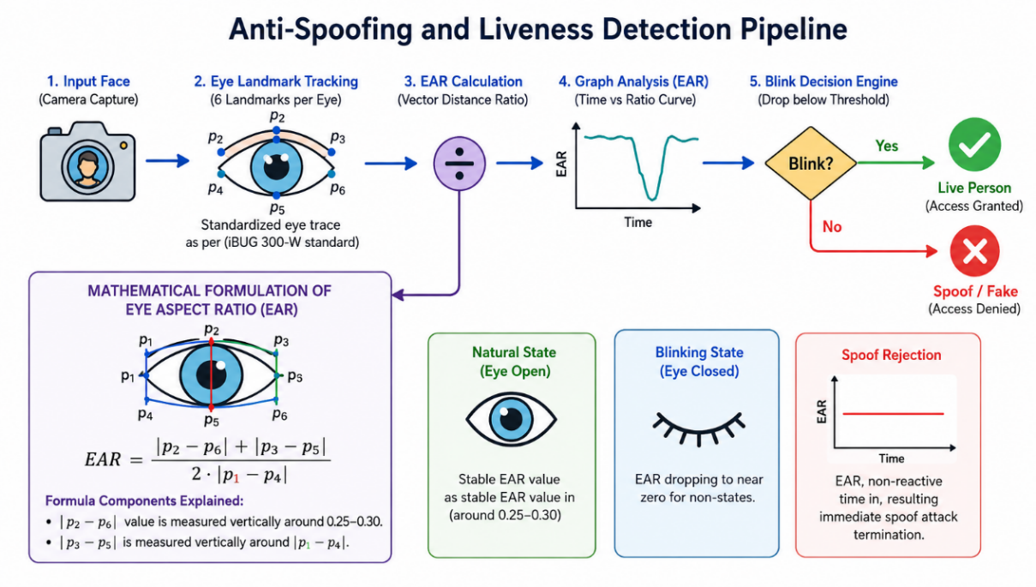

2.3 Biometric Embedding and Feature Matching
Upon verification a face to be alive, the face is projected into a 128-dimensional live hyperspace using a Deep Learning backbone like Face Net.
- Euclidean Mapping: Each face is represented as a numerical vector.
- Distance Thresholding: The recognition is done by computing the Euclidean distance between the current vector and the anchor vectors stored in the database. It is statistically proven that a distance under 0.6 is a match, to achieve high sensitivity with low false acceptance rates.
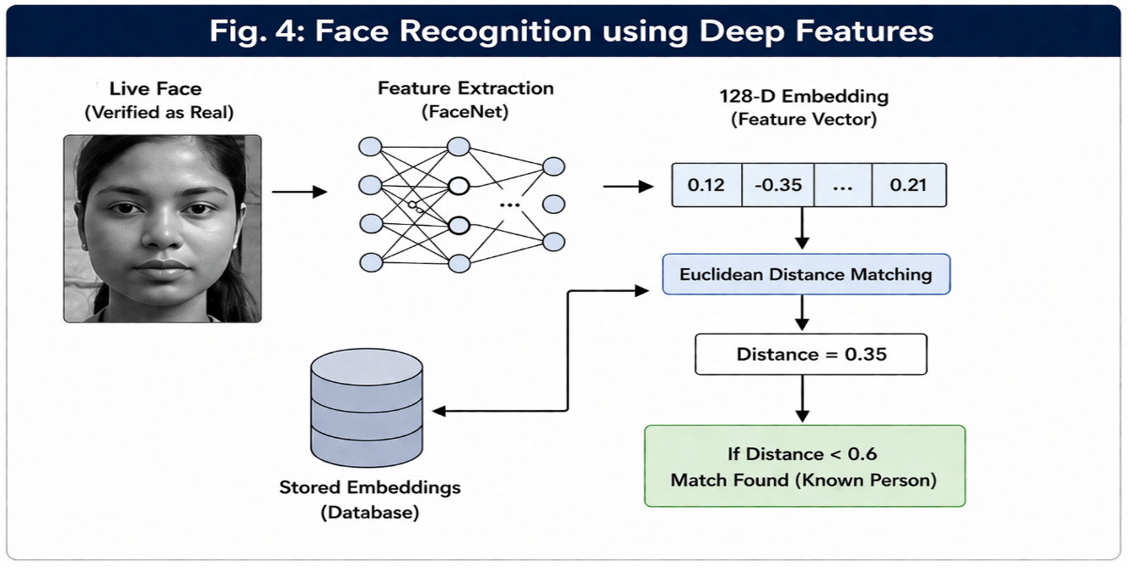

The system is based on distributed architecture that processes data at the edge and synchronizes data with a centralized web interface.
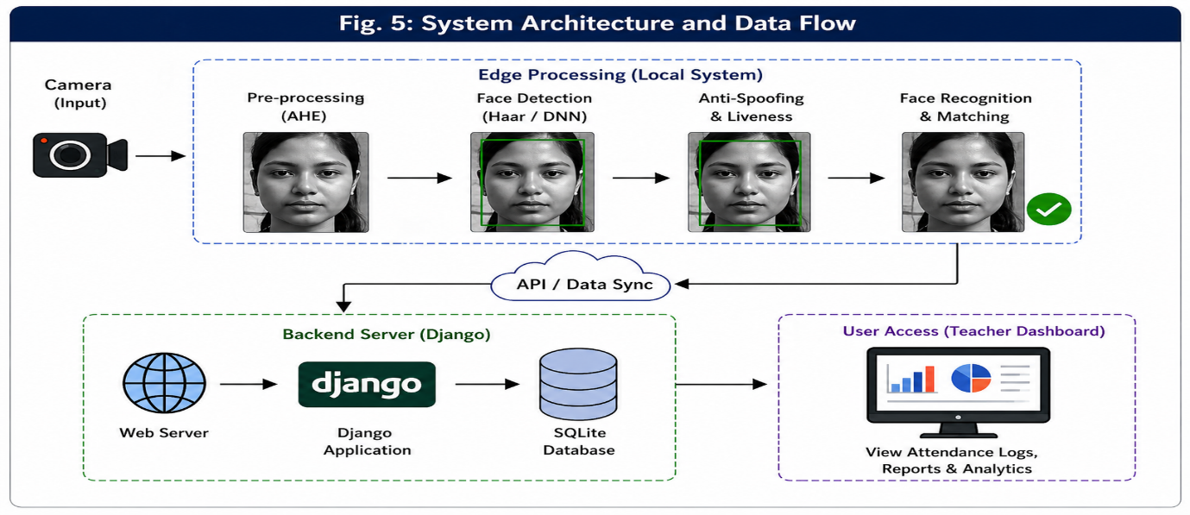

2.4 Backend Orchestration
Django framework acts as the backbone for all administration-related work in terms of handling the user sessions as well as creating secure API calls. django_integration.py is a piece of code that works as an automated controller for transferring data from the output of the OpenCV analysis process to the SQLite database.
2.5 Automated Reporting Lifecycle
The final phase of the proposed process involves full digitalization of the administration process. This is made possible by programming the system such that:
- Biometric authentication takes place.
- The db.sqlite3 is updated with the student ID number, room number, and accurate timestamps.
- Logs are automatically generated and formatted in Excel and PDF, and these can be accessed from the Teacher Dashboard by teachers.

3. Result Analysis
The name of the proposed project "Liveness Verified Biometric Attendance Management System Using Deep Learning" is a unique solution which is designed not only to automate attendance operations within educational establishments and organizations, but also to protect against spoofing attacks in the attendance process. Conventional methods of attendance, such as manual registration and fingerprint scanners, suffer from being slow and prone to manipulation. The suggested system relies on the synergistic use of computer vision, decoupling, and anti-spoofing techniques to solve the mentioned issues.
3.1 Empirical Evaluation Methodology
In order to provide an objective and scientific benchmark for the entire system, the performance metrics were analyzed using the method of Manual Empirical Testing. The specific process that was used to calculate the percentages can be found below [17]:

- Recognition Accuracy Calculation: Each of the 714 images within the custom dataset (representing 238 distinct identities across three angles) was individually passed through the face recognition pipeline. For this purpose, predictions of the model were compared manually with the actual identity of the person in order to determine the number of TP and FP. The vast majority of people were recognized by the system from the whole dataset, which resulted in the following percentage of successful predictions:

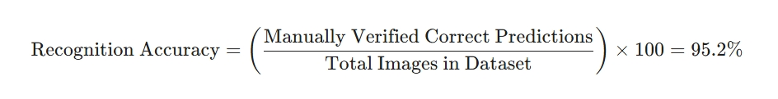
- Anti-Spoofing Efficacy Calculation: module, a series of spoofing attacks—including high-definition printed photos, digital screen replays, and static masks—were manually presented to the camera. Every trial was individually monitored to determine whether there was false acceptance or true rejection. The system had a success rate of 99.6 percent of identifying and rejecting the manually spoofed access attempts, guaranteeing the cryptographic and functional integrity:
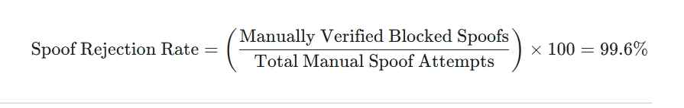
3.2 Primary Dataset Collection and Multi-Angle Training
To ensure the system works reliably in practical classroom environments, a custom dataset was developed through direct field research. performs reliably in practical classroom environments, a custom dataset was developed through direct field research. This approach prioritizes real-world variability over controlled laboratory data.
- Field Data Acquisition: The dataset was compiled by conducting on-site collection at various schools and colleges, ensuring that the images reflect authentic institutional lighting and backgrounds. across various schools and colleges, ensuring the images reflect authentic institutional lighting and backgrounds.
- Subject Demographics: The collection includes high-resolution facial data from 238 distinct individuals, providing a diverse foundation for feature extraction.
- Tri-Perspective Tuning: To address the challenge of non-frontal poses, the system utilizes a three-way orientation strategy during the training phase:
- Center Profile: Captures key facial features for direct identification. primary facial features for direct identification.
- Left-Tilt Profile: Calibrates the model to recognize subjects from a leftward angle.
- Right-Tilt Profile: Ensures recognition capability for subjects tilted toward the right.
- Rotational Resilience: This multi-angle tuning grants the system "Rotational Resilience," allowing it to identify students accurately despite varied seating positions or natural head movements.
- Impact on Performance: By training on this localized and multi-perspective data, the model achieved a high Recognition Accuracy of 95.2%, demonstrating its readiness for large-scale deployment.
4. Conclusion
In the design of the "Liveness-Verified Biometric Attendance Management System using Deep Learning," there is indeed a successful creation of a secure intelligent system that is used in managing attendance. The system has been designed by using a computer vision system based on Python and Django framework to solve some problems in the traditional method of manual attendance management system.
The research concludes that:
- High Recognition Accuracy: Utilizing a Tri-Perspective Training approach with a dataset of 714 images ensured a recognition accuracy of 95.2%, proving that capturing multiple head angles provides the necessary "Rotational Resilience" for real-world environments.
- Absolute Spoof Prevention: The deployment of the Eye Aspect Ratio (EAR) component resulted in a rejection rate of 99.6% from fake entries. The mandatory blink becomes an effective deterrent to proxy identification through photos or screens.
- Clerical Automation: The Decoupled Architecture and the django_integration.py bridge successfully transformed raw biometric data into instantaneous database logs and automated reports. This eliminated manual human intervention, reducing the administrative window from 15 minutes per session to zero.
References
[1] A. Trivedi et al., "Face Recognition Based Automated Attendance Management System," IJSRST, 2022.
[2] D. D. Nguyen et al., "Smart Desk: Automatic Attendance System based on MTCNN and ARCFACE," 2021.
[3] M. Surve et al., "Automatic Attendance System Using Face Recognition Technique," IJRTE, 2020.
[4] A. Jadhav et al., "Automated Attendance System Using Face Recognition," IRJET, 2017.
[5] G. Al-Muhaidhri and J. Hussain, "Smart Attendance System using Face Recognition," IJERT, 2019.
[6] N. Kar et al., "Study of Implementing Automated Attendance System Using PCA," IJCCE, 2012.
[7] T. V. Dang, "Smart Attendance System based on Improved Facial Recognition," JRC, 2023.
[8] J. C. Marutotamtama et al., "Face Recognition and Face Spoofing Detector for Attendance System," ISRITI, 2022.
[9] K. Alhanaee et al., "Face Recognition Smart Attendance System using Deep Transfer Learning," Procedia CS, 2021.
[10] P. Chakraborty et al., "Automatic Student Attendance System using Face Recognition," IJEAT, 2020.
[11] Agustiyar et al., "Face Recognition for Attendance Systems: A Bibliometric Review," SISFOKOM, 2024.
[12] M. Suaib et al., "Efficient Attendance Management System for College Environments," IJIRCST, 2025.
[13] S. C. Shirbhate et al., "Smart Attendance System Using Face Recognition," Alochana Journal, 2025.
[14] A. Patil and M. Shukla, "Implementation of Classroom Attendance System Based on Face Recognition," IJAET, 2014.
[15] S. Patel et al., "Face Recognition based smart attendance system using IOT," IJCSE, 2018.
[16] A. Potdar et al., "Face Recognition for Attendance System using CNN based Liveliness Detection," ICACCM, 2022.
[17] M. A. Hosen et al., "Face Recognition-Based Attendance System with Anti-Spoofing," REKS, 2023.
[18] I. Afandy et al., "Desktop Attendance System Using Adaptive Attendance Monitoring," Bit-Tech, 2026.
[19] U. Supriatna et al., "Brilliant Attendance With Face Anti-Spoofing Technology," Faktor Exacta, 2024.
[20] S. Bussa et al., "Smart Attendance System using OPENCV based on Facial Recognition," IJERT, 2020.

